IF INVOLVED FOR 1ST TIME - “WELCOME” AND THANK YOU! - IF CURRENTLY INVOLVED STILL COMPLETE SO WE CAN UPDATE RECORDS & ROSTERS:
P1 = Person 1; P2 = Person 2 (see over page)
P1 | P2 | PRAYER AND WORSHIP
 |  | Liturgical Ministry
 |  | Altar Server
 |  | Cantor
 |  | Children’s Liturgy of the Word
 |  | Choir
 |  | Collector at Mass
 |  | Extraordinary Minister of Eucharist
 |  | Flower Arrangements
 |  | Hospitality & Welcome (Provide a warm welcome to all parishioners and visitors at Sunday Mass)
 |  | Instrument ( )
 |  | Laptop Operators
 |  | Liturgy Planning
 |  | Minister of Communion to the Sick
 |  | Reader
 |  | Sacristan (Funerals)
 |  | Sacristan (Liturgy Preparation)
 |  | Washing Altar Linen
 |  | Prayer Groups & Pilgrimages
 |  | Charismatic Prayer Group
 |  | Pilgrimages
P1 | P2 | SERVICE AND MISSION
 |  | Outreach
 |  | Bereavement Group
 |  | Home Visitation
 |  | St Vincent de Paul Society
 |  | Youth Adults
 |  | True North Young Adults (18-35yo)
 |  | Young Couples & Families
 |  | Young Couples & Families Network
 |  | Hospitality and Community
 |  | Book Club (S)
 |  | Friday Morning Tea (S)
 |  | Project Circle – Craft Group (S)
 |  | Social Get Together (MP)
 |  | Supper/Morning Tea after Mass
 |  | Welcome New Parishioners
 |  | Safeguarding
 |  | Child Safety Officer at Mass
 |  | Safeguarding Committee
P1 | P2 | EDUCATION AND FORMATION
 |  | Baptism Preparation Team
 |  | Christian Initiation of Adults (RCIA)
 |  | Christian Initiation of Children (RCIC)
 |  | Sacramental Preparation
 |  | Adult Faith Formation
 |  | Advent & Lenten Reflection Groups
 |  | Alpha
 |  | Other Adult Education/Formation
 |  | Retreat Days
 |  | Scripture Study
 |  | Parish Maintenance & Care
 |  | Church Cleaning/Vacuuming
 |  | Gardening Team
 |  | Maintenance Team
Working Bee Group – handyman or tradesman (please specify your skills)
………………………………………………………….
 |  | ………………………………………………………….
 |  | ………………………………………………………….
Is there a Ministry or Group that you are interested in seeing established?
Share some details and we will be in touch
Working with Children Check (WWCC)
Requirement
All volunteers aged over 18 are required to have a WWCC. There is no cost for volunteers and the Parish Office is happy to assist with your application. Our policies and procedures can be found on our parish website:
www.stmonicasparish.com.au

Which is your usual Mass?

6.00pm Saturday
8.30am Sunday
9.30am Sunday
10.30am Sunday
5.30pm Sunday

Our Details
Name: (P1)
(P2)
Address:

Tel:
Mob (P1):

Mob (P2): ____________________________

Email: ________________________________
Date of Birth (P1): ______/______/
Date of Birth (P2): ______/______/

We need you!

Share your gifts, talents, and energy to build our parish community.

PLEASE RETURN THIS FORM
AT THE RENEWAL PROGRAM

COMMITMENT WEEKEND MASSES
SATURDAY 8 and SUNDAY 9 JUNE

OR

TO THE PARISH OFFICE BY
WEDNESDAY 12 JUNE
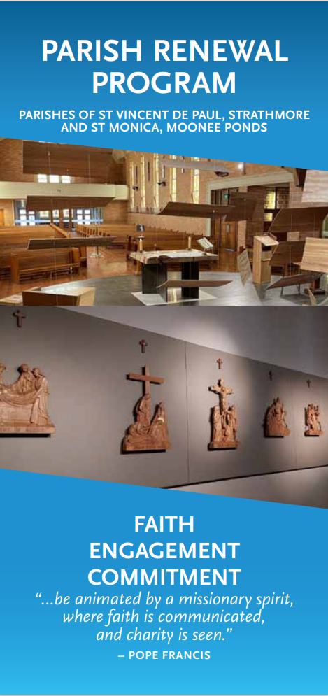
“For we are what He made us, created in
Christ Jesus for good works.”
Eph 2:10

